**Tharun Bejawada (1919111509)**

**29. Junit Testing to Check Whether the Calculated simple interest is valid or not**

**AIM**

To Perform junit Testing to Check Whether the Calculated simple interest is valid or not

**PROGRAM**

package sse;

import static org.junit.Assert.assertTrue;

import java.util.Scanner;

class intrest

{

public static void main(String[] args)

{

Scanner sc=new Scanner(System.in);

float P=sc.nextFloat();

float R=sc.nextFloat();

float T=sc.nextFloat();

float SI = (P * T * R) / 100;

System.out.println("Simple interest = " + SI);

assertTrue(12000==SI);

}

}

**OUTPUT**

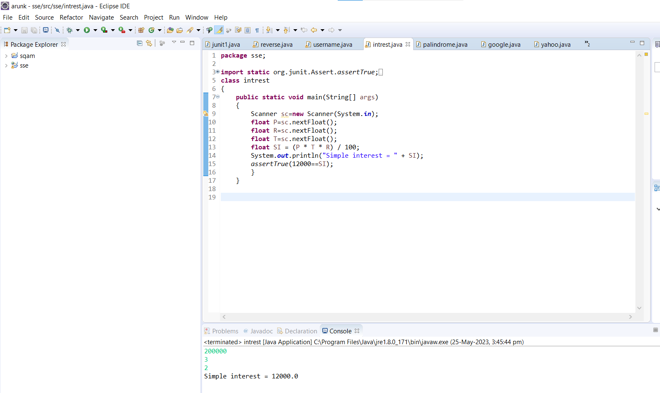

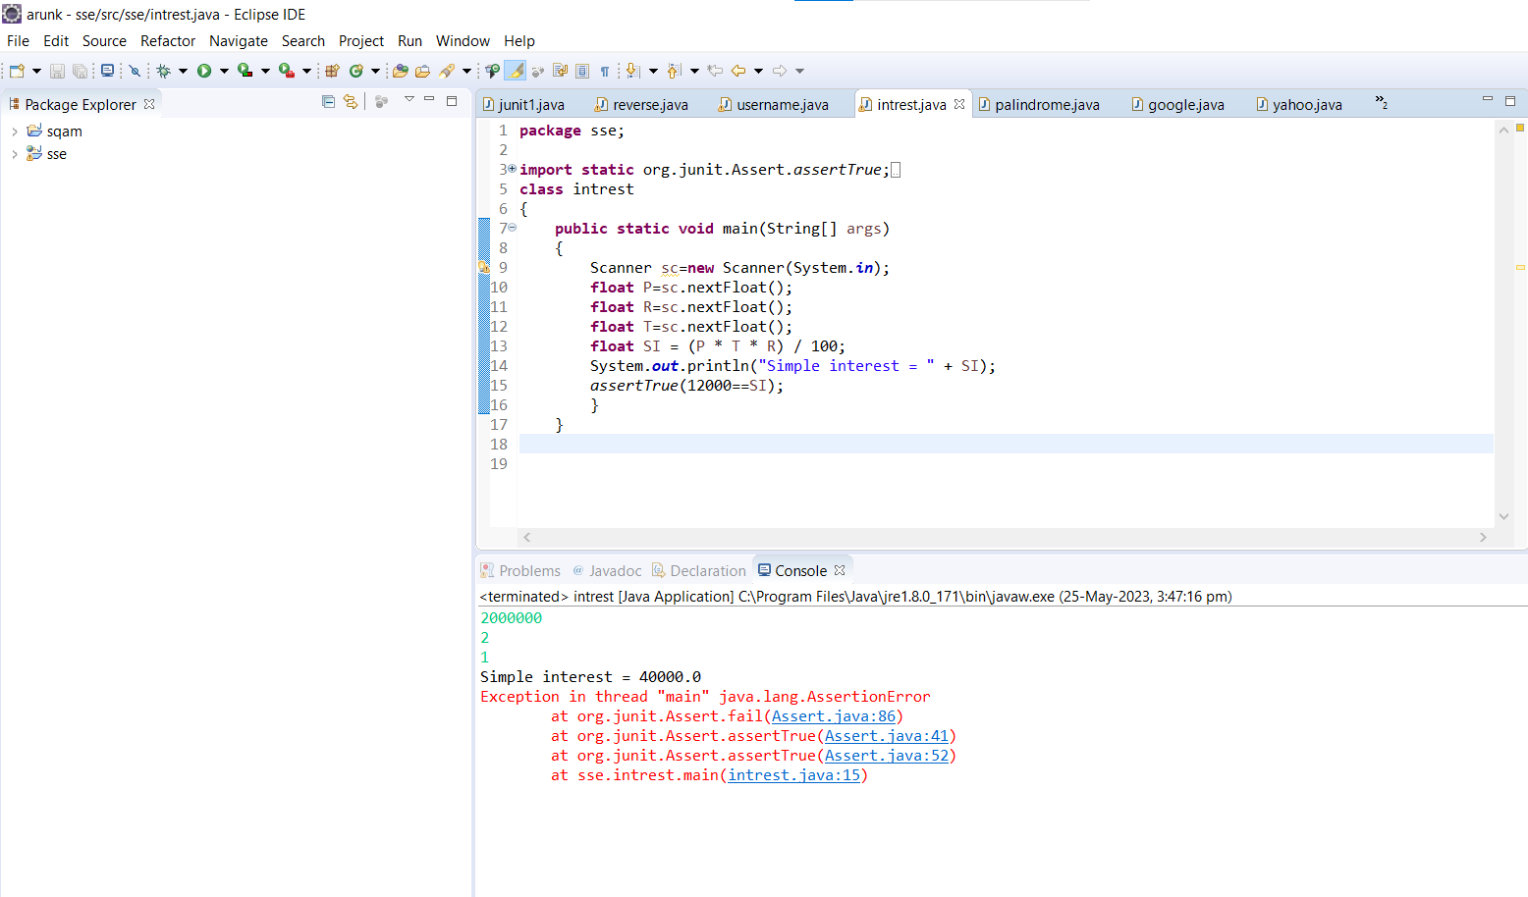

**RESULT**

Hence the junit Testing Check Whether the Calculated simple interest is valid or notperformed successfully.